Table of Contents

Executive Summary 3

Introduction 4

User Requirements 5

General Functionality 5

Section – Specific Functionality 5

Site Goals 6

Mission or Purpose of the Organisation 6

Short Term Goals 6

Long Term Goals 7

Intended Audience 7

Attraction to the Website 8

Section Two – User Experience 8

Audience Definition 8

Scenarios 10

Competitive Analysis Summary 12

Competitor No – 1 (Breast Cancer Foundation NZ) 12

Competitor 2 (Breast Cancer Cure) 16

https://www.breastcancercure.org.nz/ 16

Competitor 3 (BCAC – Breast Cancer Aotearoa Coalition) 19

Section Three Site Content 21

Content Grouping and Labelling 21

Functional Requirements 22

Metaphors 22

**Metaphor Exploration – Functional Metaphor** 22

**Metaphor Exploration – Visual Metaphor** 22

Section 4 Site Structure 23

Site Structure Listing 23

Sitemap 24

Section 5 – Visual Design 25

Layout Grids 25

Home Page Layout 26

Breast Cancer Page Layout 28

Breast Awareness Page Layout 30

About - Us Page Layout 32

Book an Appointment Page Layout 34

Sign-Up Page Layout 36

Section 5 CRUD Analysis 38

CRUD Table 38

API Prototype 38

References 39

# Executive Summary

This report can be used as a client document which will show how the Breast Cancer Charity website will be created to showcase the client’s idea of promoting breast cancer awareness amongst the youth. This document presents the recommended steps that are documented for building an effective functional website as per the industry standard. The goal of this document is to show you a prototype of the website for your intended audience.

We are recommending on building this website using Express for the API and Angular and Vue for the front end. Since the client requirements are customized, we recommend building this website from scratch instead of using any CMS to build it. This website will be built by us as developers and it will be easier if we maintain it too as any customization can only be done in the code, which we are unsure if the client is comfortable changing. But that decision is for the client to make if they would like to maintain the website on their own or if they would like us to maintain it for them.

Below is the link to the GitHub Link to the website: -

<https://github.com/praptimane26/BreastCancerCharity>

So far, we’ve built the API for the Task Manager of the website, which will allow an user to Create, Update, Retrieve and Delete a list. The next phase would be to build the API for the Login System and the Booking System, and accordingly build the Front-end using Angular and Vue.

# Introduction

After receiving the brief from client and what their expectation is towards the website, we’re providing this report as a document to understand how important it is to have a functional website, using Angular for the front-end of the website which the users see on the website, for the backend we will be using Express and Node.js and to maintain the users and their database we will be using Mongo, the reason we cannot use a CMS for this website is because the client wants a customised website with very specific needs, hence we thought building this website from scratch would be the way to go.

Below is the brief that we received from the client:

The Breast Cancer Charity is about promoting breast cancer awareness and encouraging women and men to get regular check-ups and not avoid their health. This would be a charity website, helping communities spread awareness and provide free check-ups to anyone who registers as a user on the website. The website also provides a task management system just to keep the user on track with their check-ups, they can create tasks about their routine check-ups and can also be as a To-Do list. There will also be a booking system to redeem the token for free breast cancer check-up that will be emailed to the users when they register on the website.

In this report we have focused on the specific areas of the website, we have identified the potential visitors for the website, and how they would use the website, the functionality of the website and the goals too.

# User Requirements

## General Functionality

We think a functional website for you would contain images which would be related to breast cancer as images is what usually catches the user’s attention, we will also have a video and text that will help promote the website. We will also have a task manager on the website which will help the user to keep a list of their health for example they can make a note of when their next home breast cancer check-up should be done etc. The website also provides one free breast cancer check-up to all the users that register on the website. A user can create a task edit it and even delete it depending on their requirement. Having **Home**, **About Us**, **Breast Awareness**, **Breast Cancer**, **Support** as the primary navigation will help the users direct to the areas, they are interested in. Also having a **Login** button on the top right of the website will help users to login or register on the website. And a **booking system** where the users can redeem their coupon to book the free breast cancer check-up.

## Section – Specific Functionality

The specific sites on the pages could be :-

1. **About Us** – This page will contain all the information about the Breast Cancer Charity. What it is about and what their goals are. It will also display information of the founders of the website and their reason behind starting the Breast Cancer Charity.
2. **Breast Awareness** – This page will contain information about how to take care of your breasts. A video of how to check your breasts properly. This page will also have information about mammograms, risk factors and inherited risks.
3. **Breast Cancer** - This page will hold information about types of breast cancer, tests and diagnosis and the treatments available.
4. **Book an appointment** - This page is where the users will redeem their token to book a free Breast cancer check-up on the Breast Cancer Charity website.

# Site Goals

## Mission or Purpose of the Organisation

The purpose of the website is to spread breast cancer awareness amongst the masses. It will be used to educate people on how to take care of their health before it is too late. Since ACC does not cover most breast cancer drugs and treatments which are very expensive as Chemo alone costs thousands of dollars, it is better to take precaution, this is the message that the website wants to put out. The website will focus on creating awareness, support, treatment options, task manager which will be helpful for the user, as detected at an early stage it is easy to cure. Breast Cancer charity wants people over 20 years to focus and understand their bodies and notice any changes as quickly as possible.

## Short Term Goals

The short-term goals of the website is to produce a mock-up of the Breast Cancer Charity website. This website will be functional, and it will help gather attention to the charity.

## Long Term Goals

The long-term goals of the website are to have a functional and fully completed website which will be used to register new users and promote the charity as much as possible by providing free check-ups to the users who register on the website. It will also be used as a task manager by the users to keep track of their health and check-ups.

The registration on the website will be helpful to promote the Charity and its benefits of spreading breast cancer awareness, as well as be beneficial for the users to get free check-ups, and when they users register, they get a token emailed to them which they can redeem on the booking system of the website.

## Intended Audience

The people that we think will be visiting the website in no particular order are: -

1. Breast Cancer Patients.
2. Doctors.
3. Charity members and anyone operating within the Charity.
4. Admin Access members
5. Women from all ages.
6. Men from all ages.
7. Other Supporting Charities.
8. Support Clinics.
9. Breast Cancer Patients Families.
10. The media/press to promote Breast Cancer Awareness.
11. Local Government to promote Breast Cancer Awareness.
12. Central Government to promote Breast Cancer Awareness.

## Attraction to the Website

Some ways in which the new website can be promoted is by: -

1. Creating a Google campaign to promote the website, hence we need to make sure the content on the landing pages is in the format that will help promote the website and use the right keywords. Google business is the best tool to do this, since this is not an e-commerce website and a charity website, doing online campaigns will be more beneficial and price efficient.
2. Creating a Facebook Page and running a Facebook can be helpful as well, to promote the website and gain more users.
3. The charity members can also create an event where they will give free breast cancer check-ups to people who show up for the event, all they need to do is at the venue register on the Breast Cancer Charity website and get their free check-up on the spot, this event can be promoted using Facebook.

# Section Two – User Experience

## Audience Definition

Breast Cancer Charity want the users to be able to register on the website and receive a token to book a free appointment for the breast cancer check-up and also use the free task manager which is available to use on the website.

The Breast Cancer Charity website will have many different types of users which were listed previously in the Intended Audience heading.

1. Breast Cancer Patients – Patients who suffer from Breast Cancer and are looking for support and more information about Breast Cancer.
2. Doctors – Doctors all over New Zealand can recommend the charity to their patients who are in the age between 20yrs old to 69yrs old. They can use the website in front of the patients to show its benefits.
3. Charity members and anyone operating within the Charity – The charity members will use the website to talk to sponsors as well as if they have the admin access, they can use it to manage the content and to check how many users the website has and how is it gaining popularity etc.
4. Admin Access members – Admin access members will use this website to maintain content on the website and post events etc.
5. Women from all ages – These are the users that we want to register on our website, as it will help create awareness, these women will come to the website to register and book their free check-up.
6. Men from all ages – These can register on the website to book a free appointment for themselves or their partners, wives, mothers etc.
7. Other Supporting Charities – Hospital charities like St. Johns etc can also promote the Breast Cancer Charity to their patients, to spread awareness. Show them the website to help them realize that they can get free check-ups and use the task manager to create tasks depending on their health etc.
8. Support Clinics – Support clinics can show their patients how beneficial the Breast Cancer Charity website and its workings and how they can claim a free check-up.
9. Breast Cancer Patients Families – The families of patients who are suffering from Breast Cancer will visit to website, to get themselves checked, as well as to gain more information about Breast Cancer as it will be helpful for them.
10. The media/press to promote Breast Cancer Awareness – The media/press will visit the website to understand what it is and how it works and promote the website to get locals and people are New Zealand to get free check-ups done.
11. Local Government to promote Breast Cancer Awareness – Local government will visit the website, to probably connect with the charity members to come up with certain schemes or to help promote the website to spread Breast Cancer awareness especially around breast cancer month which is from 1st October – 31st October.
12. Central Government to promote Breast Cancer Awareness - Central government will visit the website, to probably connect with the charity members to come up with certain schemes or to help promote the website to spread Breast Cancer awareness especially around breast cancer month which is from 1st October – 31st October.

Let us look at the scenarios which will help describe their common reasons to visit the Breast Cancer Charity website.

## Scenarios

**Scenario 1 – Breast Cancer Patients**

Kaitlyn is a 45-year-old breast cancer patient (woman). She wants to keep a track of her progress and the tests she needs to do, she needs to use a task manager, but the task manager also needs to make her relate to it, what is better than a website about Breast Cancer awareness which also helps maintain a task list and acts as a task manager.

**Scenario 2 – Breast Cancer Charity, Member**

Daniel is one of the founding members of the Breast Cancer Charity and wants to update the content on the Breast Cancer Charity website. Daniel wants to list on the website that apart from the free check-up that the users will get when they register on the website, they will also at the venue get some free goodies from the new Sponsor. To do this Daniel needs to go into the back end of the website and add this new information. Just like Daniel any other charity member who has the admin access can make these changes as well. They can control what offers are available for users of the website.

**Scenario 3 – 30-year-Old woman**

Misa is a 30-year-old woman, she has never gotten a breast cancer check up done she hears that on the Breast Cancer Charity website if you register as a user you get a token for free breast cancer check-up. So, she gets on the website, hits the login button types in her email and password and registers as a new user, after doing that she gets a token send to her email which she can use to redeem a free breast cancer check-up on the website to book her appointment using the booking system.

**Scenario 4 – 20-year-old man**

Kevin saw on a Facebook group page that Breast Cancer Charity is giving out free breast cancer check-ups for anybody who registers as a user on the website, he wants to book a free breast cancer check-up for his mother, hence he opens up the Breast Cancer Charity website and registers is mother as a user and then he tell his mother that she can use the booking system on the website to book her free check-up using the token that has been emailed to her.

# Competitive Analysis Summary

Competitor No – 1 (Breast Cancer Foundation NZ) <https://www.breastcancerfoundation.org.nz/>

4

3

1

2

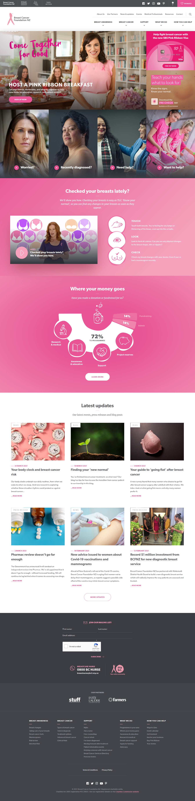

5

Breast Cancer Foundation NZ is one of the biggest Breast Cancer charities in New Zealand. They are based out of Auckland, New Zealand. Their website is a very good one, it has all the information a user would need in fact much more, but I do find their banner a little too busy. Other than the banner the website is very well made, and the colours are very nice too. Their website does look like it has been maintained professionally also it was built professionally. Their website is build in React and few other libraries using php.

1. I cannot tell if this is their primary navigation or their secondary navigation.
2. This feels like a primary navigation and contains the information that the user will be after. I do not like the idea of having both the primary and secondary navigation on the homepage displayed separately.
3. I do like the idea of having social media plugins in the header it makes it much easier for users to follow the social media pages.
4. The Donate button is located perfectly in the header as it’s easy to spot and it will be very helpful for users who come to the website to support the cause.
5. The banner is very busy according to me it has a lot going on, there is app information, visa card information and even a sign up for the breakfast club, this could easily confuse users.

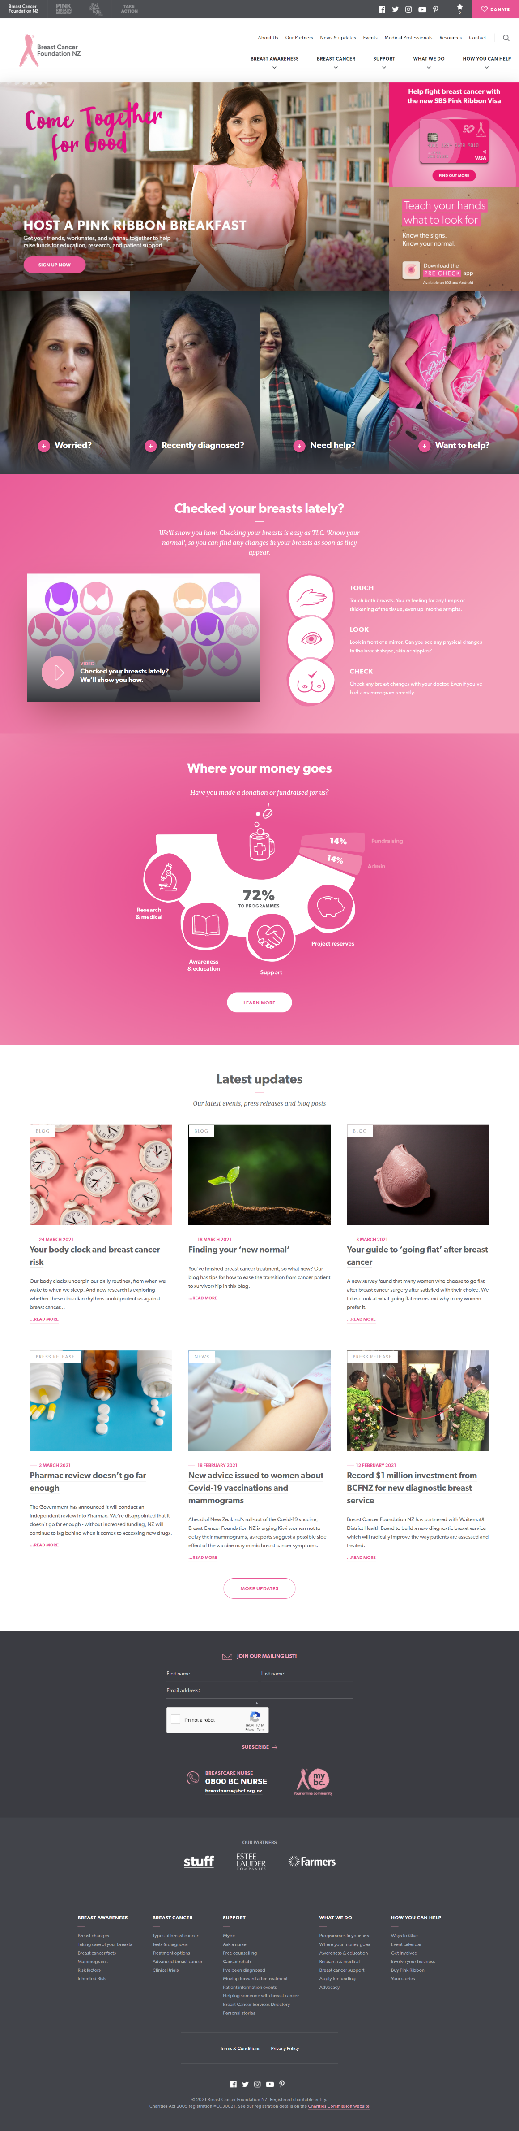

7

6

1. This is a very good spot to place the video as it is on the homepage and something that will be helpful for the users.
2. The learn more button takes you to the page which gives a detailed report of how the money that has been donated is being used, this is a good feature if the site generates big chuck of donations.

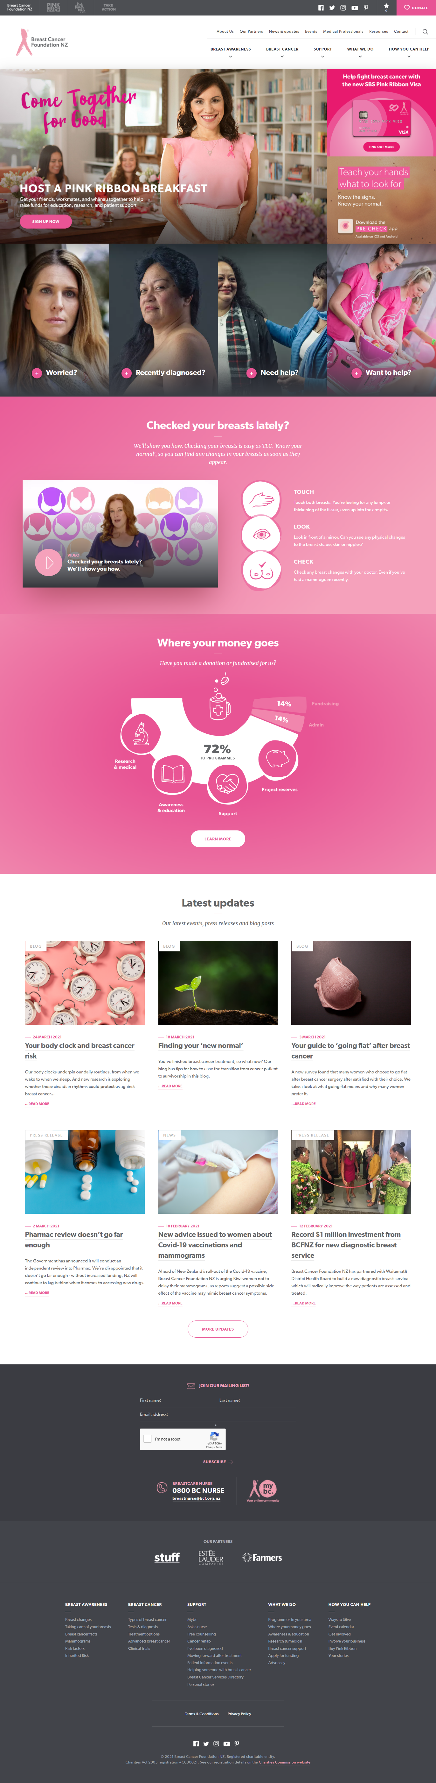

8

1. The website does write blogs regularly and has regular press releases hence having them place on the homepage is a good idea, but having just 3 blogs/press release articles would’ve been a better option than having 6 blogs. But the white space does make the website look nicer.
2. This more updates button directs the user to the blog page where all these blogs live.



10

1101

9

1. The subscribe button needs a border because it just seems like simple text or if they even increase the font it will make it obvious as a button.
2. They have repeated the links in the navigation bar, which is a good practice for footers but also, they have linked all the hidden pages, it makes it easier for the user to just get directed to the exact link they are looking for, if they don’t want to scroll through the entire website.
3. Since the website does have their social media icons in the header, I do not see the point of having in the footer as well. They should sit either in the header or the footer not both.

## Competitor 2 (Breast Cancer Cure)

## <https://www.breastcancercure.org.nz/>

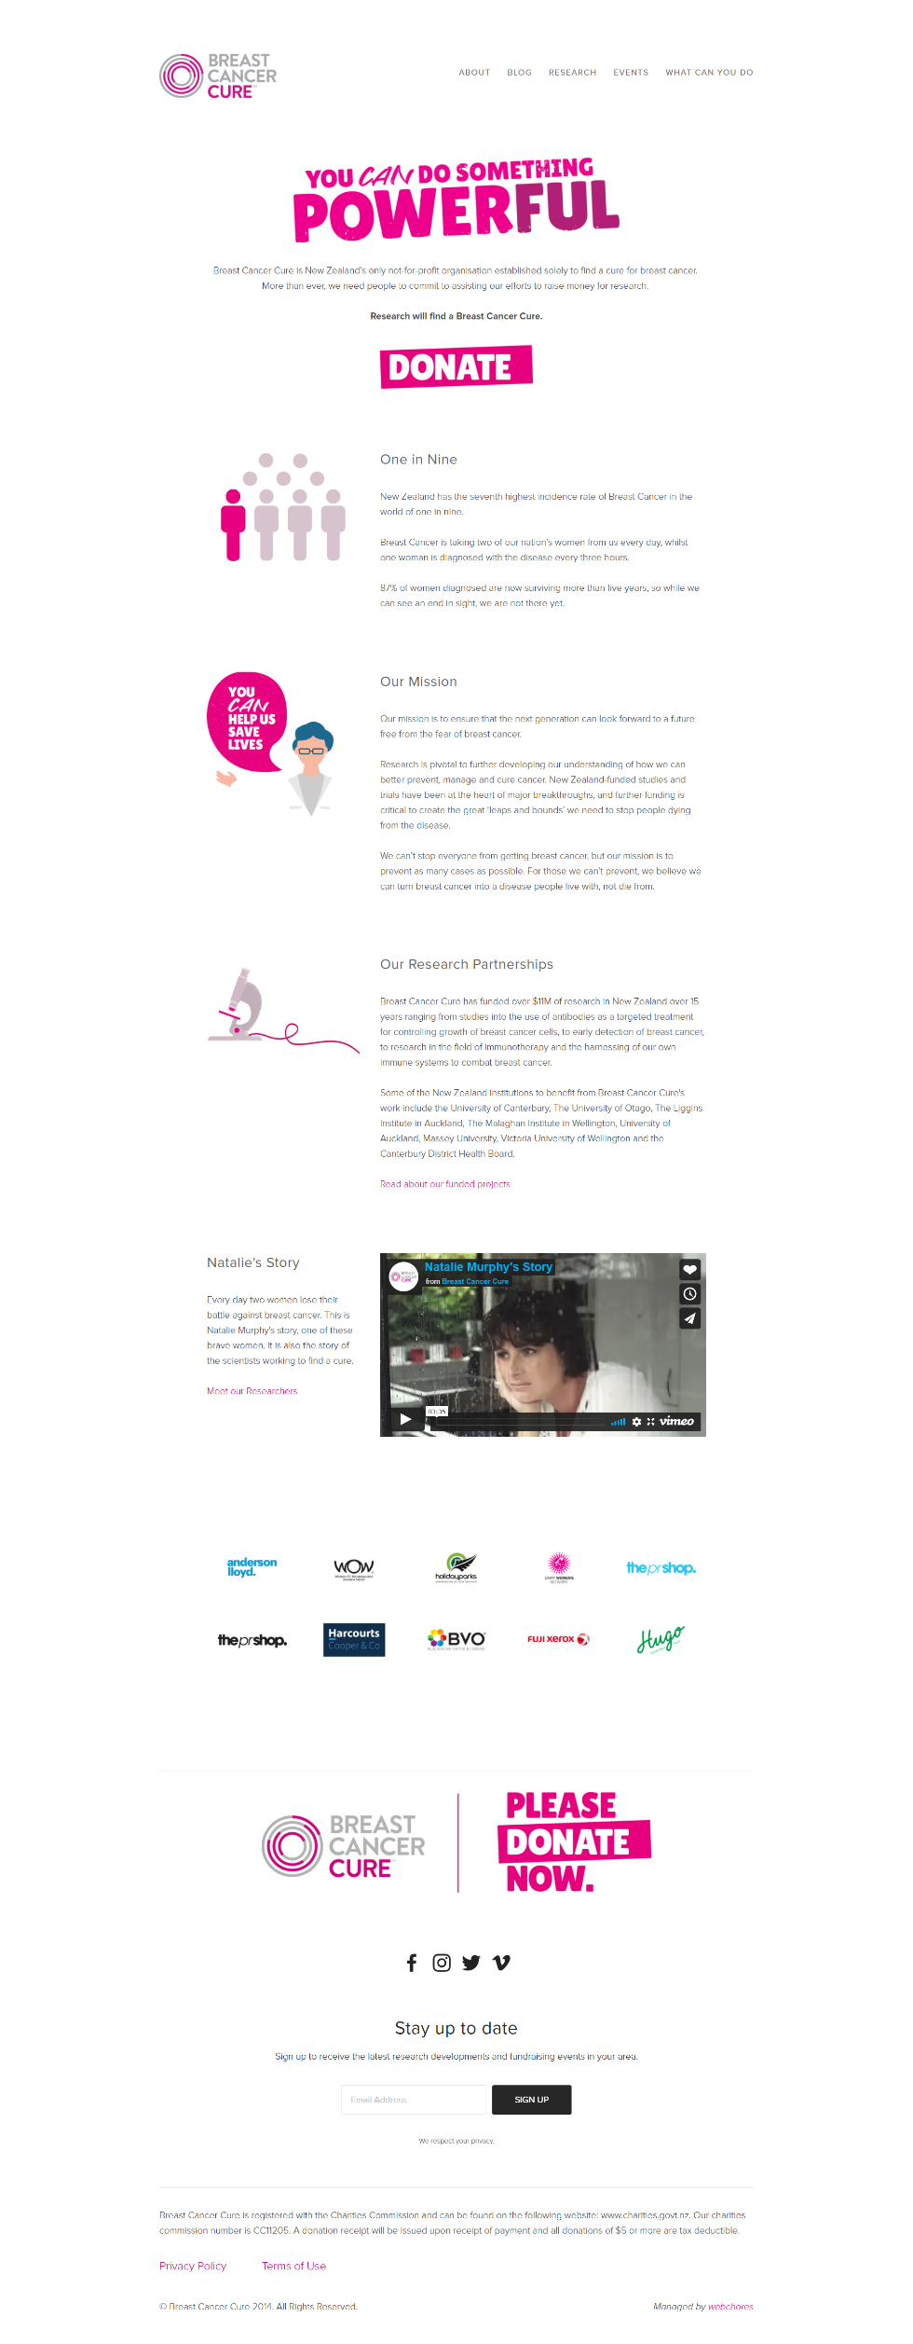

2

3

1

Breast Cancer Cure is also an Auckland based charity. The website is clean and a bit old fashioned. The functionality of the website is good, but the layout and UI are old. The colours are good, and it is a clean website.

1. The primary navigation looks good, but the secondary navigation is a bit complicated, I have never seen contact in “about” tab before, it took a couple of minutes to find their contact info.
2. The secondary dropdowns in the “what you can do” tab is very helpful, as the user knows that is where they will find the information, they are looking of especially if they want to donate or volunteer etc.
3. The Video is placed well on the homepage with some background story about the person who is in the video telling their story, this is a good idea, as instead of just having a written story it is better to have a video where they are talking about their experiences.
4. This is where the sponsors have been listed which I thought was a very good idea, but since our charity has no sponsors now, we won’t be using this feature, but it can be used at a later stage.
5. This is where the website has placed their social media icons, which is usually how the old websites did it.
6. This is where the users can sign up which could be in the header instead of having it in the footer, as it is not convenient for users to find it.

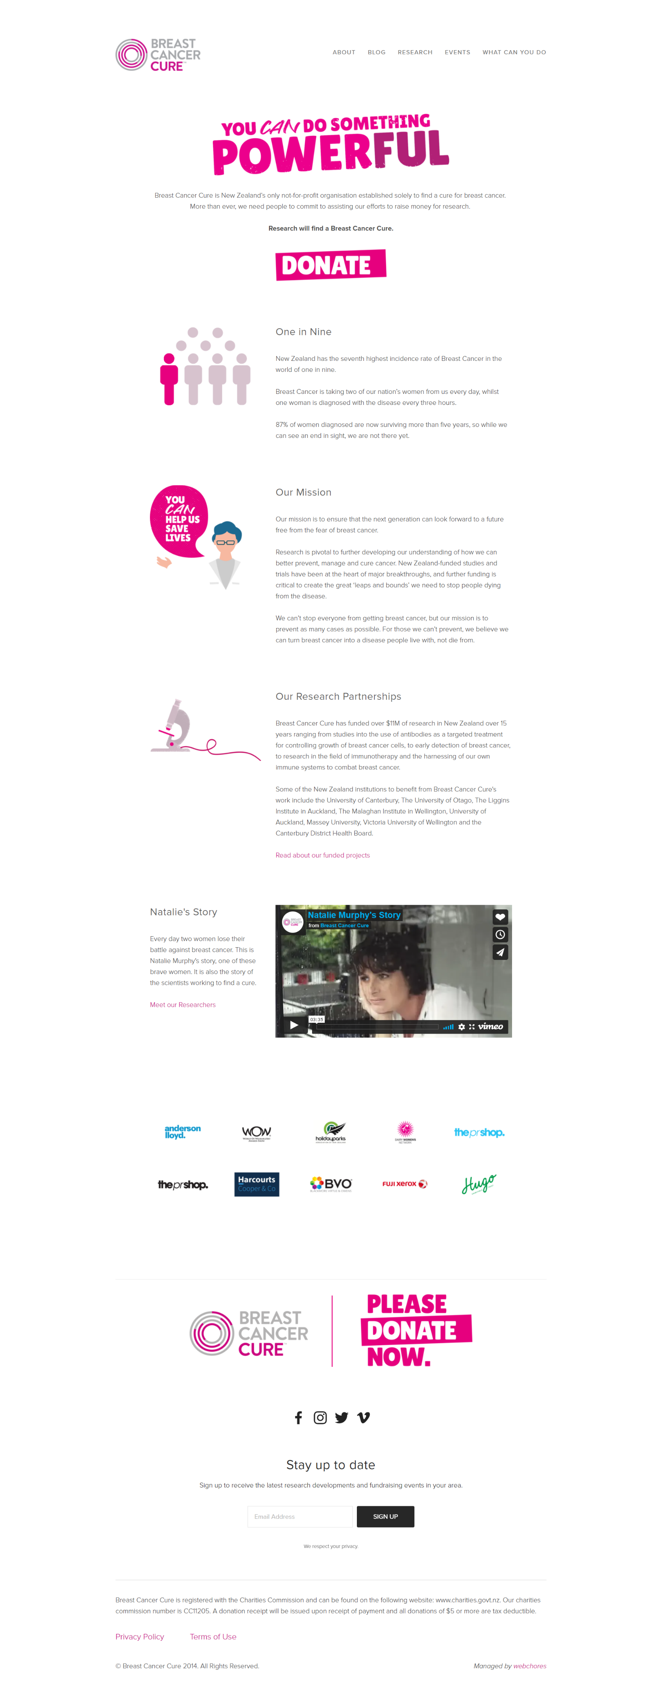

6

5

4

## Competitor 3 (BCAC – Breast Cancer Aotearoa Coalition)

<https://www.breastcancer.org.nz/>

3

2

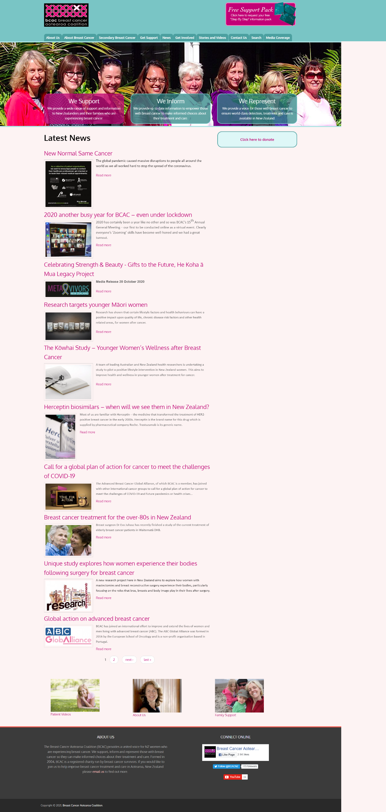

5

4

1

This website is badly designed, this is also a New Zealand based breast cancer charity.

1. The primary navigation is overcrowded.
2. The support pack is very confusing, it is not very clear, looks out of design.
3. The logo is not designed properly, it looks out of place does not go with the brand or it’s colours.
4. The donate button looks out of place, it is just placed where they could find space.
5. The home page does not have much but just the articles and the blogs.
6. The footer has the entire Facebook page widget in it. It makes the footer look bad.

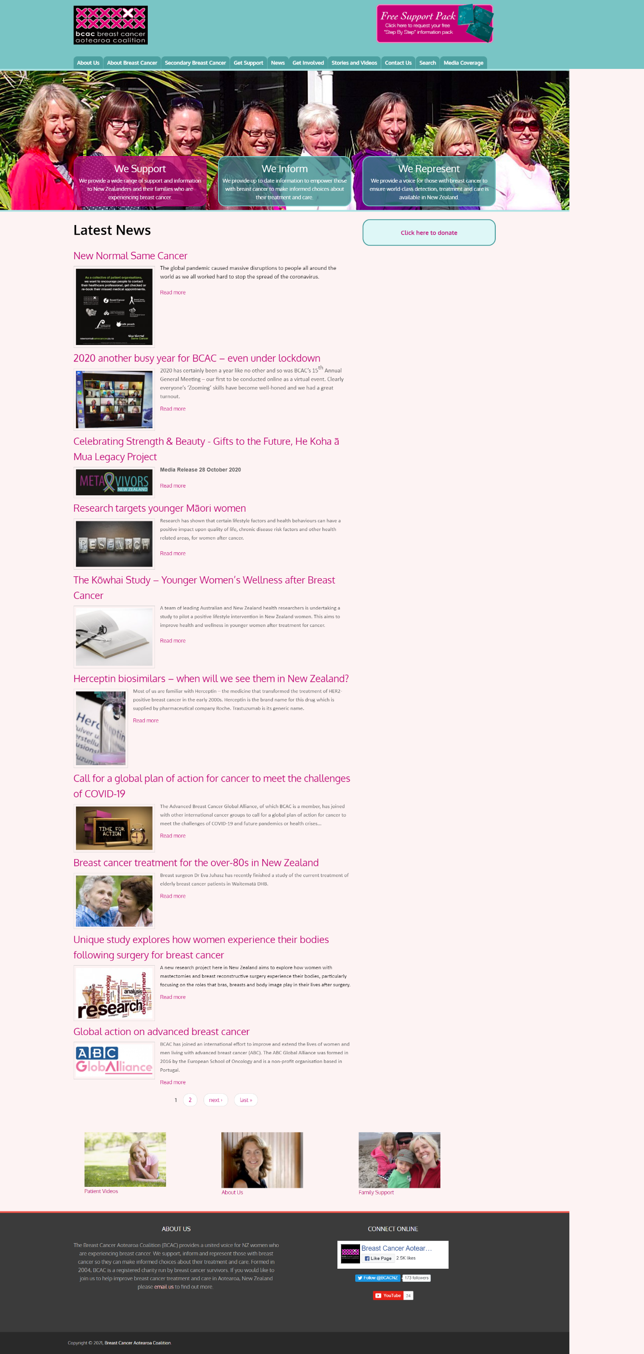

6

# Section Three Site Content

## Content Grouping and Labelling

Taking into consideration the Breast Cancer Charity and the way the client wants the charity to work, and their requirements, we have decided to divide the content of the pages as stated below:

1. Home Page

* Banner Image
* Video of a Breast Cancer Patient
* Book an Appointment.
* Task Manager.

1. Breast Cancer Page

* Introduction about Breast Cancer and Image
* Treatment Options, Tests & Diagnosis
* Types of Breast Cancer
* Breast Cancer Story

1. Breast Awareness Page

* Banner Image
* How to take care of your Breasts video and text
* Difference in Nipples or New Lump

1. About Us Page

* Banner Image
* Information about Breast Cancer Charity
* Image and Text about Breast Cancer Charity

1. Book An Appointment Page

* Appointment Booking System

1. Sign-Up Page

* Sign – Up system

## Functional Requirements

The functional requirement of the website is to create Breast cancer awareness amongst the youth.

As per the client brief the main functional requirements of the website is a login function, a task manager, and a booking system. A log in function will help the user register on the website and get a token emailed to them which can be used to book an appointment for a free check-up using the booking system on the page. The website should also have a task manager which will help the user maintain their tasks for regular medical check-ups.

So a booking system will be embedded in the website, and a task manager as well along with a user login system in place.

Since this is a customised website, the user will have to go into the code to change any information on the website.

## Metaphors

## **Metaphor Exploration – Functional Metaphor**

Functional metaphors are the tasks that a user can perform on the website, below listed are all the functional metaphors for the Breast Cancer Charity website.

* Registering on the website
* Signing into the website
* Adding a task to the list, editing the list, or deleting the list
* Booking an appointment on the website

## **Metaphor Exploration – Visual Metaphor**

Visual metaphors relate common graphics elements on your site to others familiar out in the world.

* Banner Images
* Patient Video
* Breast Cancer check Video
* Pink, Grey, Black colours (main color Pink)

# Section 4 Site Structure

## Site Structure Listing

The navigation for the Breast Cancer Charity website will be straight forward and easy for a user to use. After doing the Competition analysis we have come up with the navigation, also making sure it meets the client’s requirements.

* On the top left of the website will be the logo which will also be linked to the homepage.
* Next to the logo to the right side will be the search button with search field.
* Next to the search button will be the Facebook plugin for the Facebook page.
* Next to the Facebook plugin will be the Sign-up button which the user will use to Register or Login to the website.
* Below will the primary navigation with the following pages:
* Breast Cancer Page
* Breast Awareness Page
* About Us Page
* Book an Appointment Page

When the user lands on a page that page will be highlighted in the navigation letting the user know their position on the website. If the user is on the home page none of the navigation tabs will be highlighted.

## Sitemap

Global Navigation

Cloud

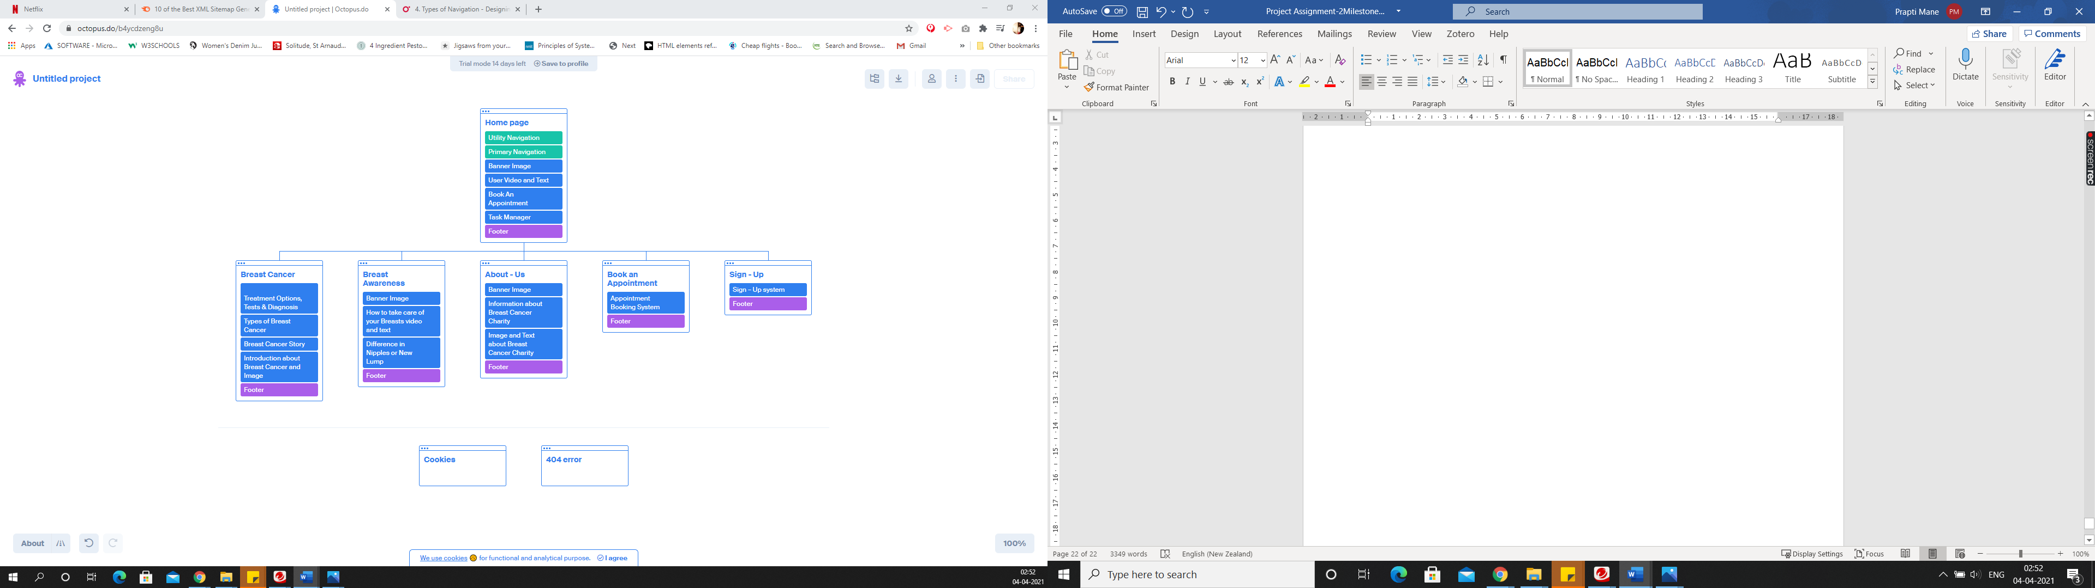

Database

# Section 5 – Visual Design

## Layout Grids

Below are the wireframes and mock-ups for the Breast Cancer Charity website. The wireframe is created using <https://wireframe.cc/>.

The mock-ups of the pages are created using “Justin Mind” which is an application for windows to create Mock-ups.

There are a total of 6 pages:-

1. Home Page
2. Breast Cancer Page
3. Breast Awareness Page
4. About – Us Page
5. Book an Appointment Page
6. Sign – Up Page

## Home Page Layout

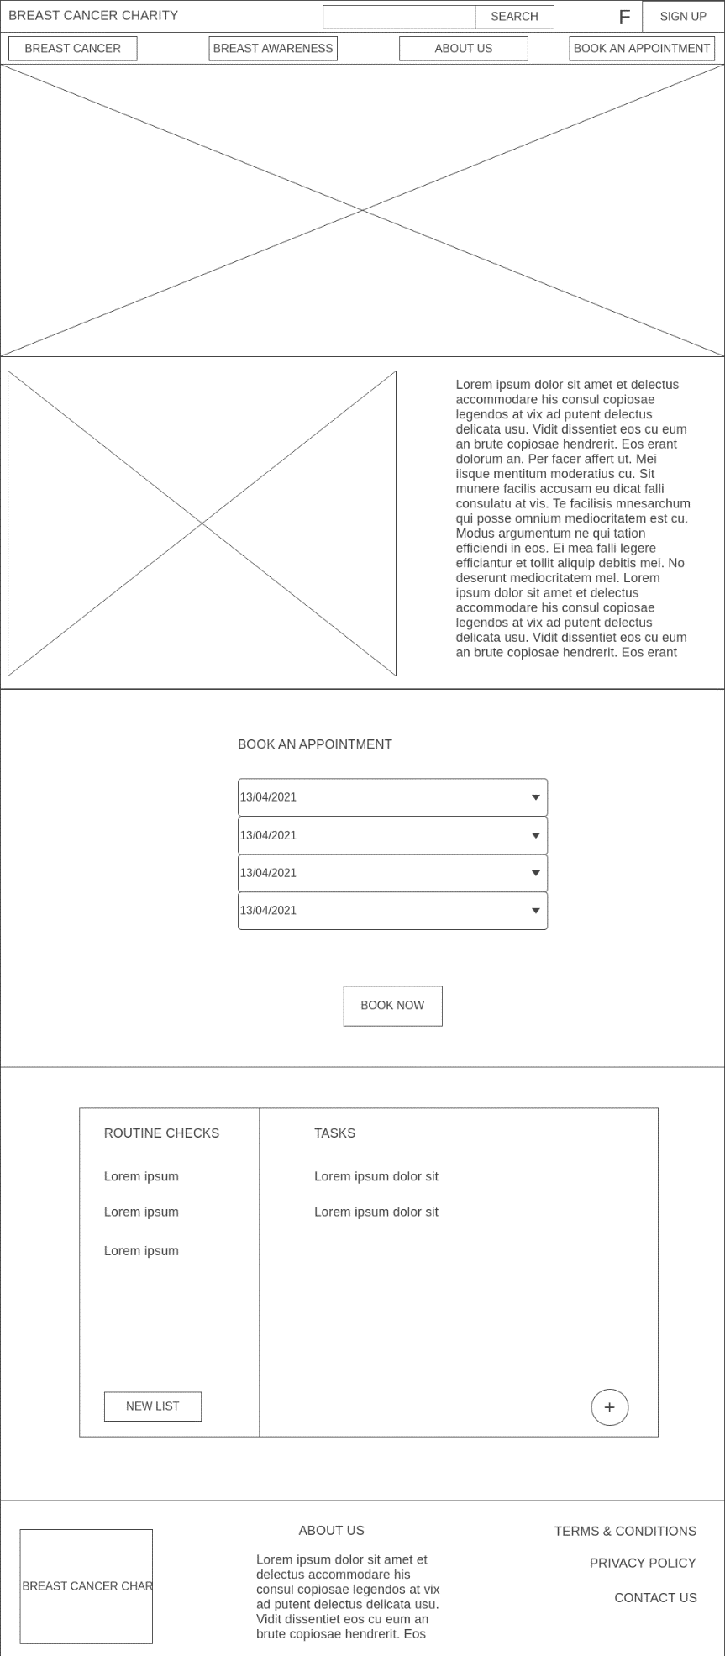

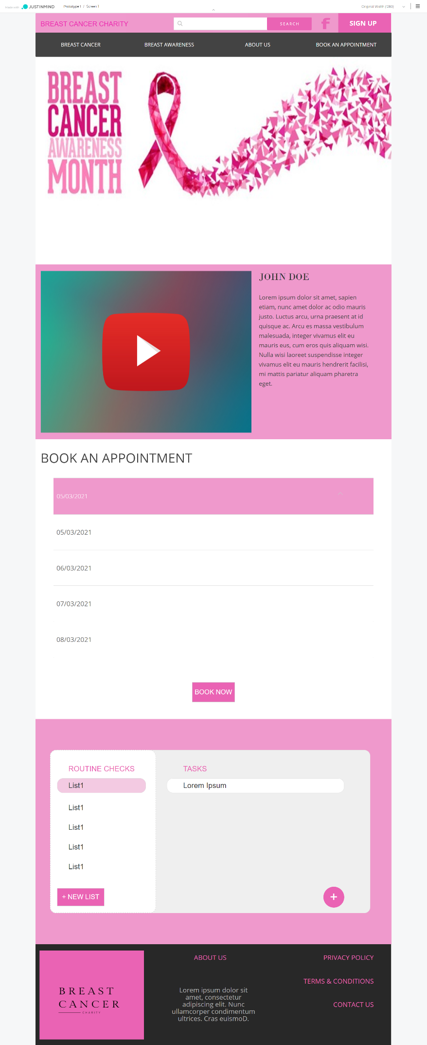

## Breast Cancer Page Layout

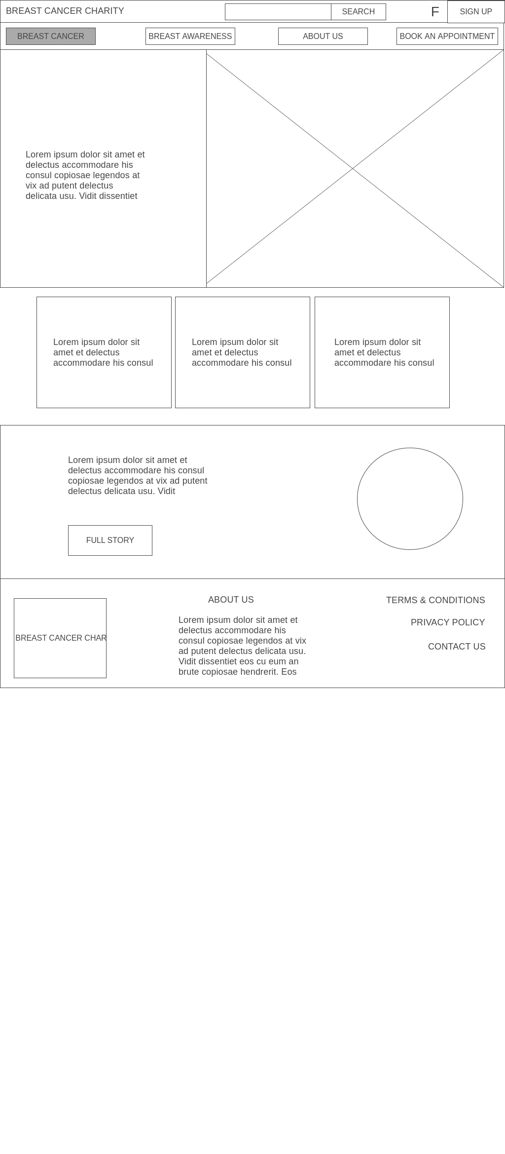

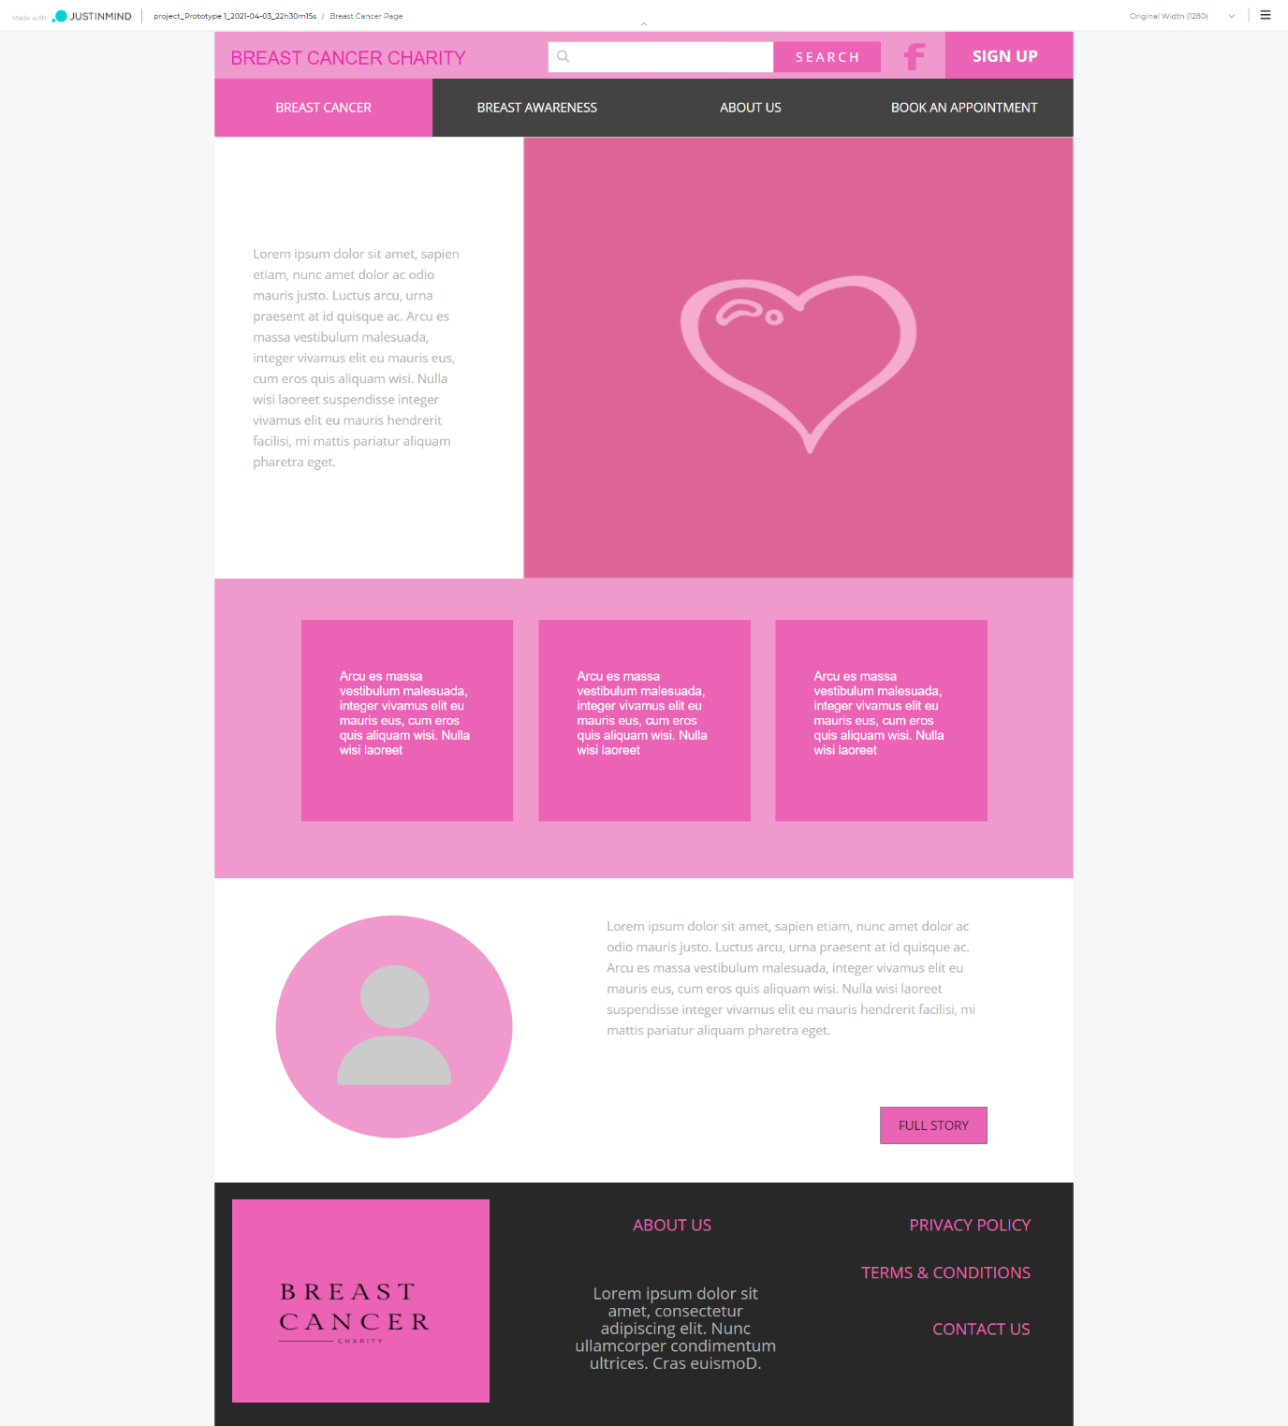

## Breast Awareness Page Layout

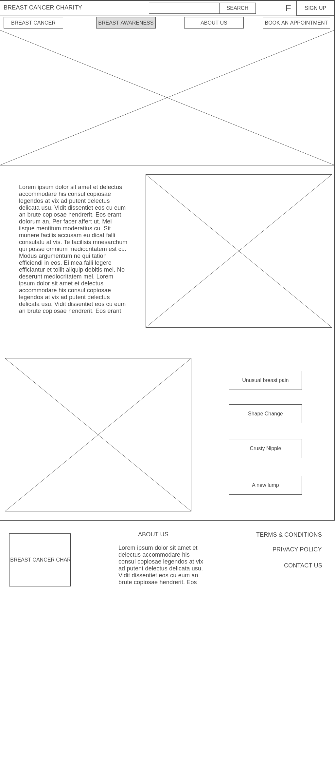

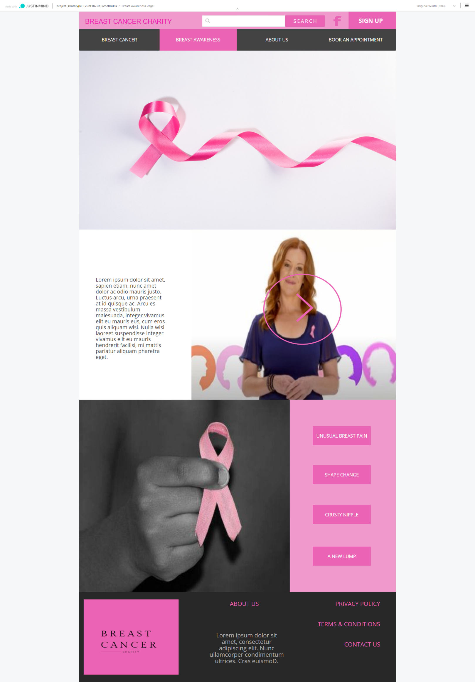

## About - Us Page Layout

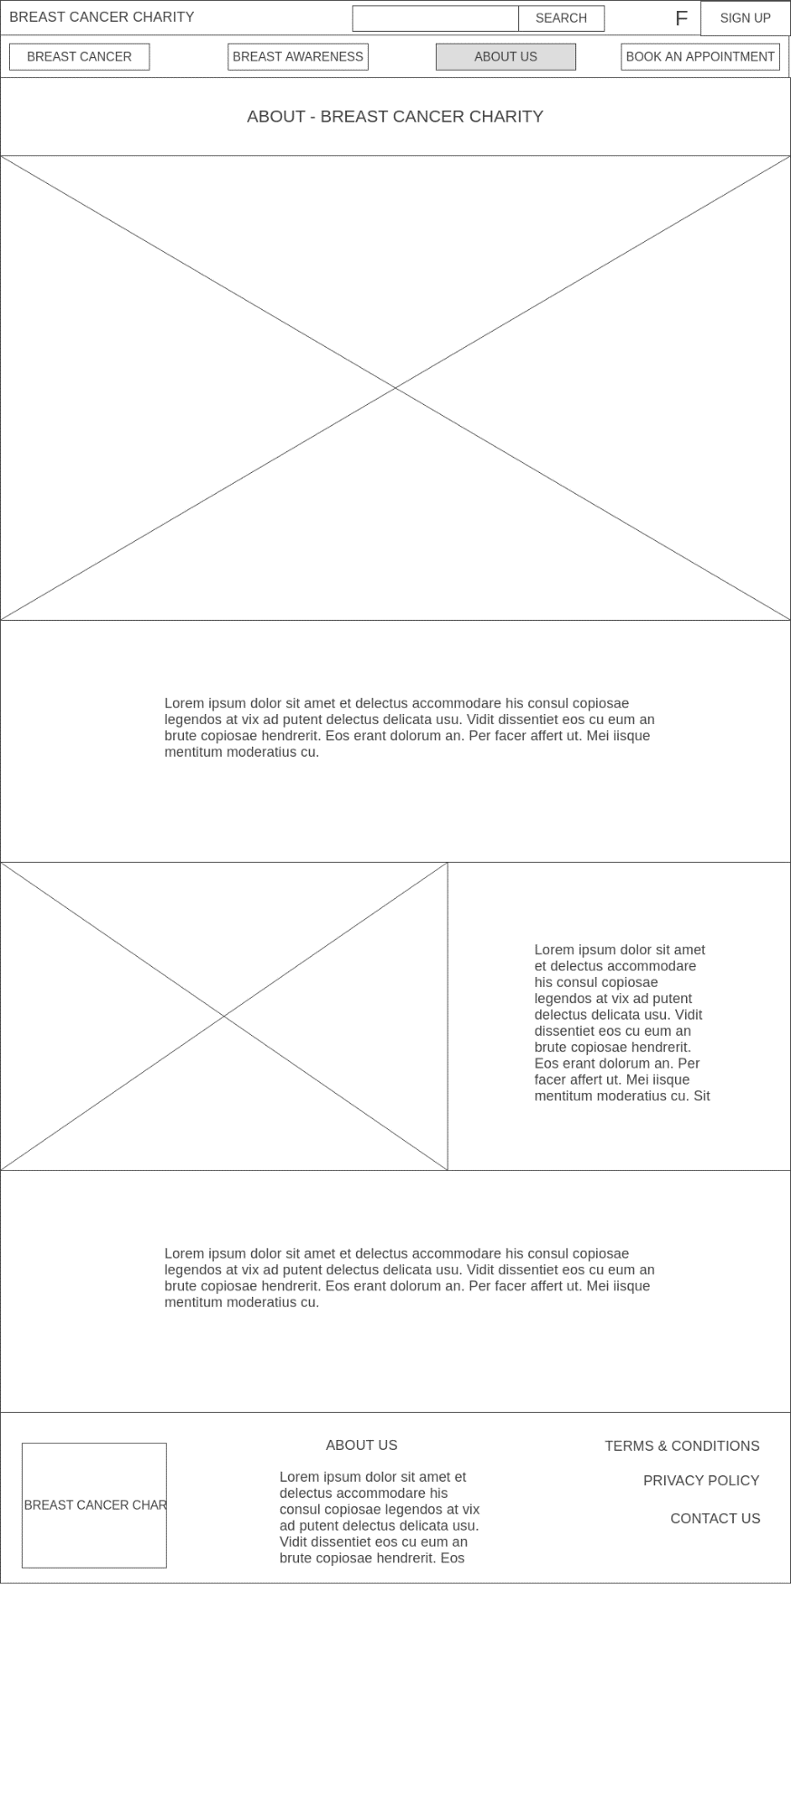

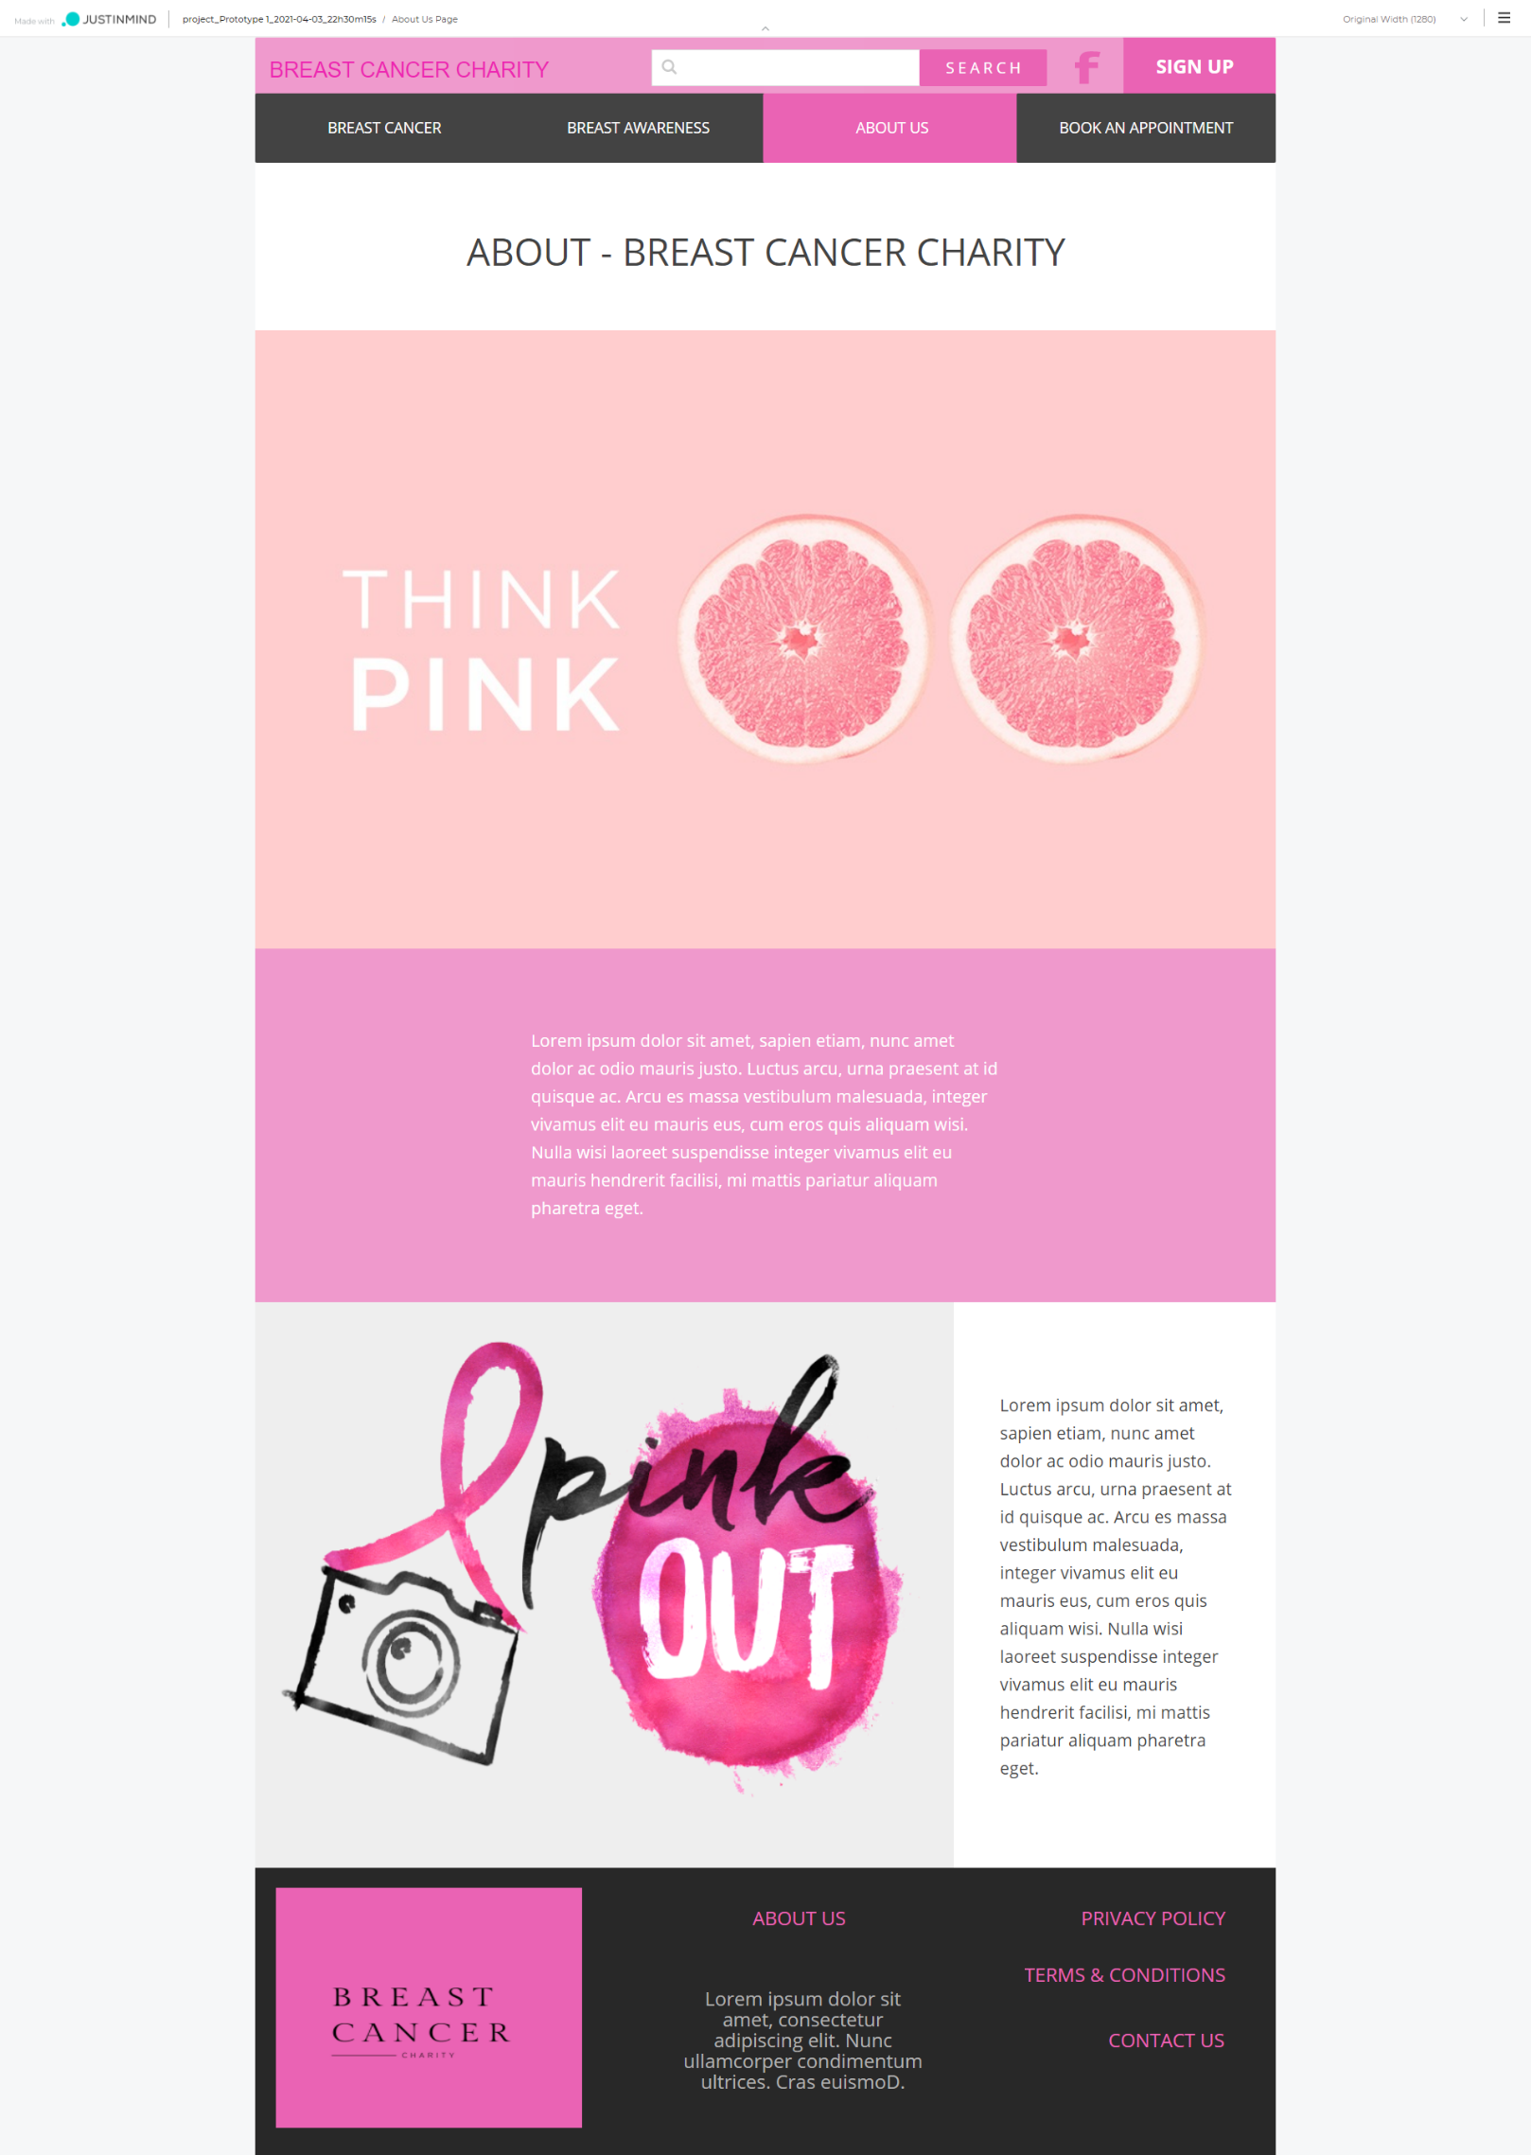

## Book an Appointment Page Layout

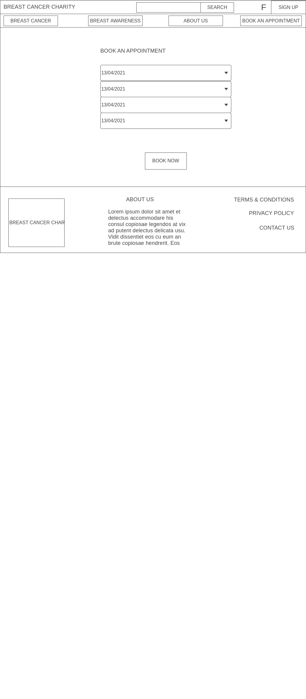

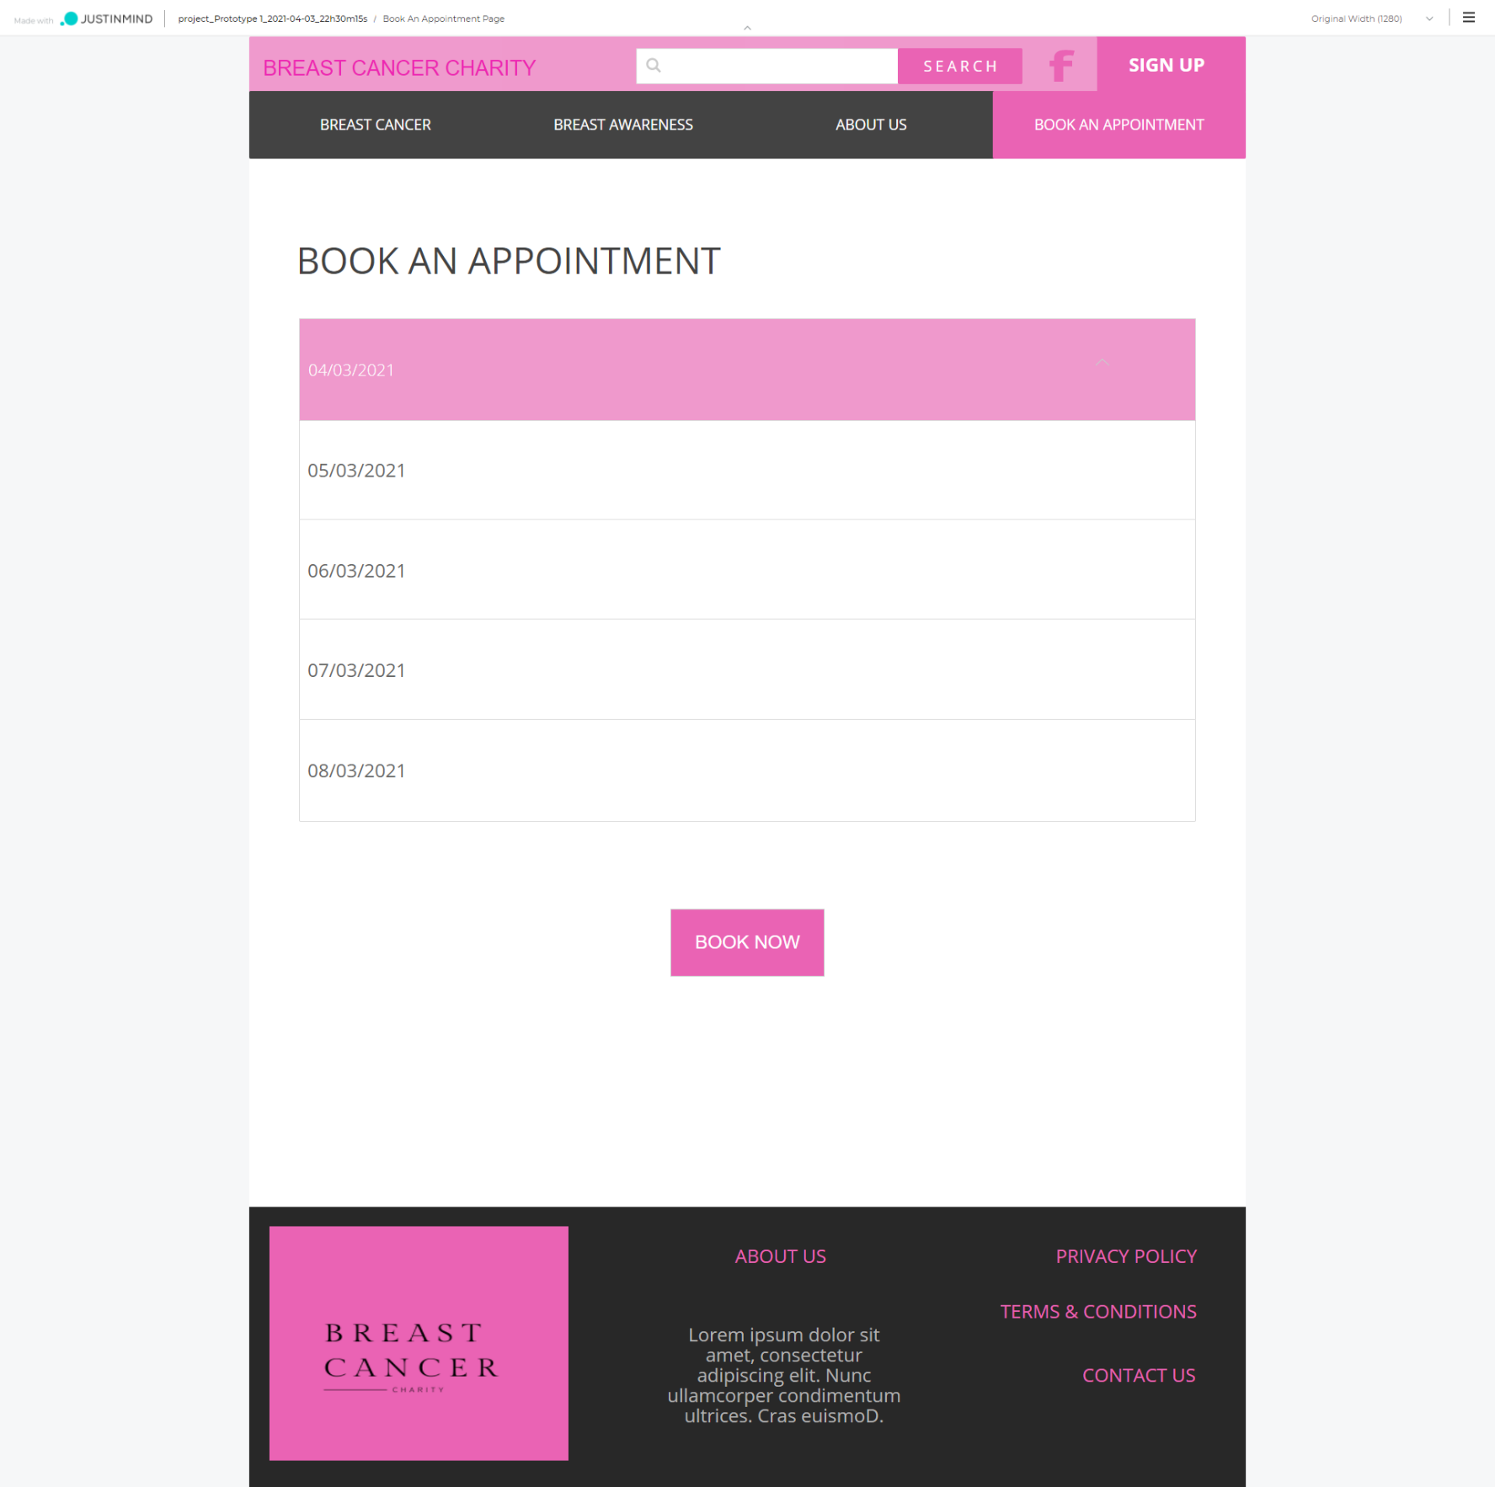

## Sign-Up Page Layout

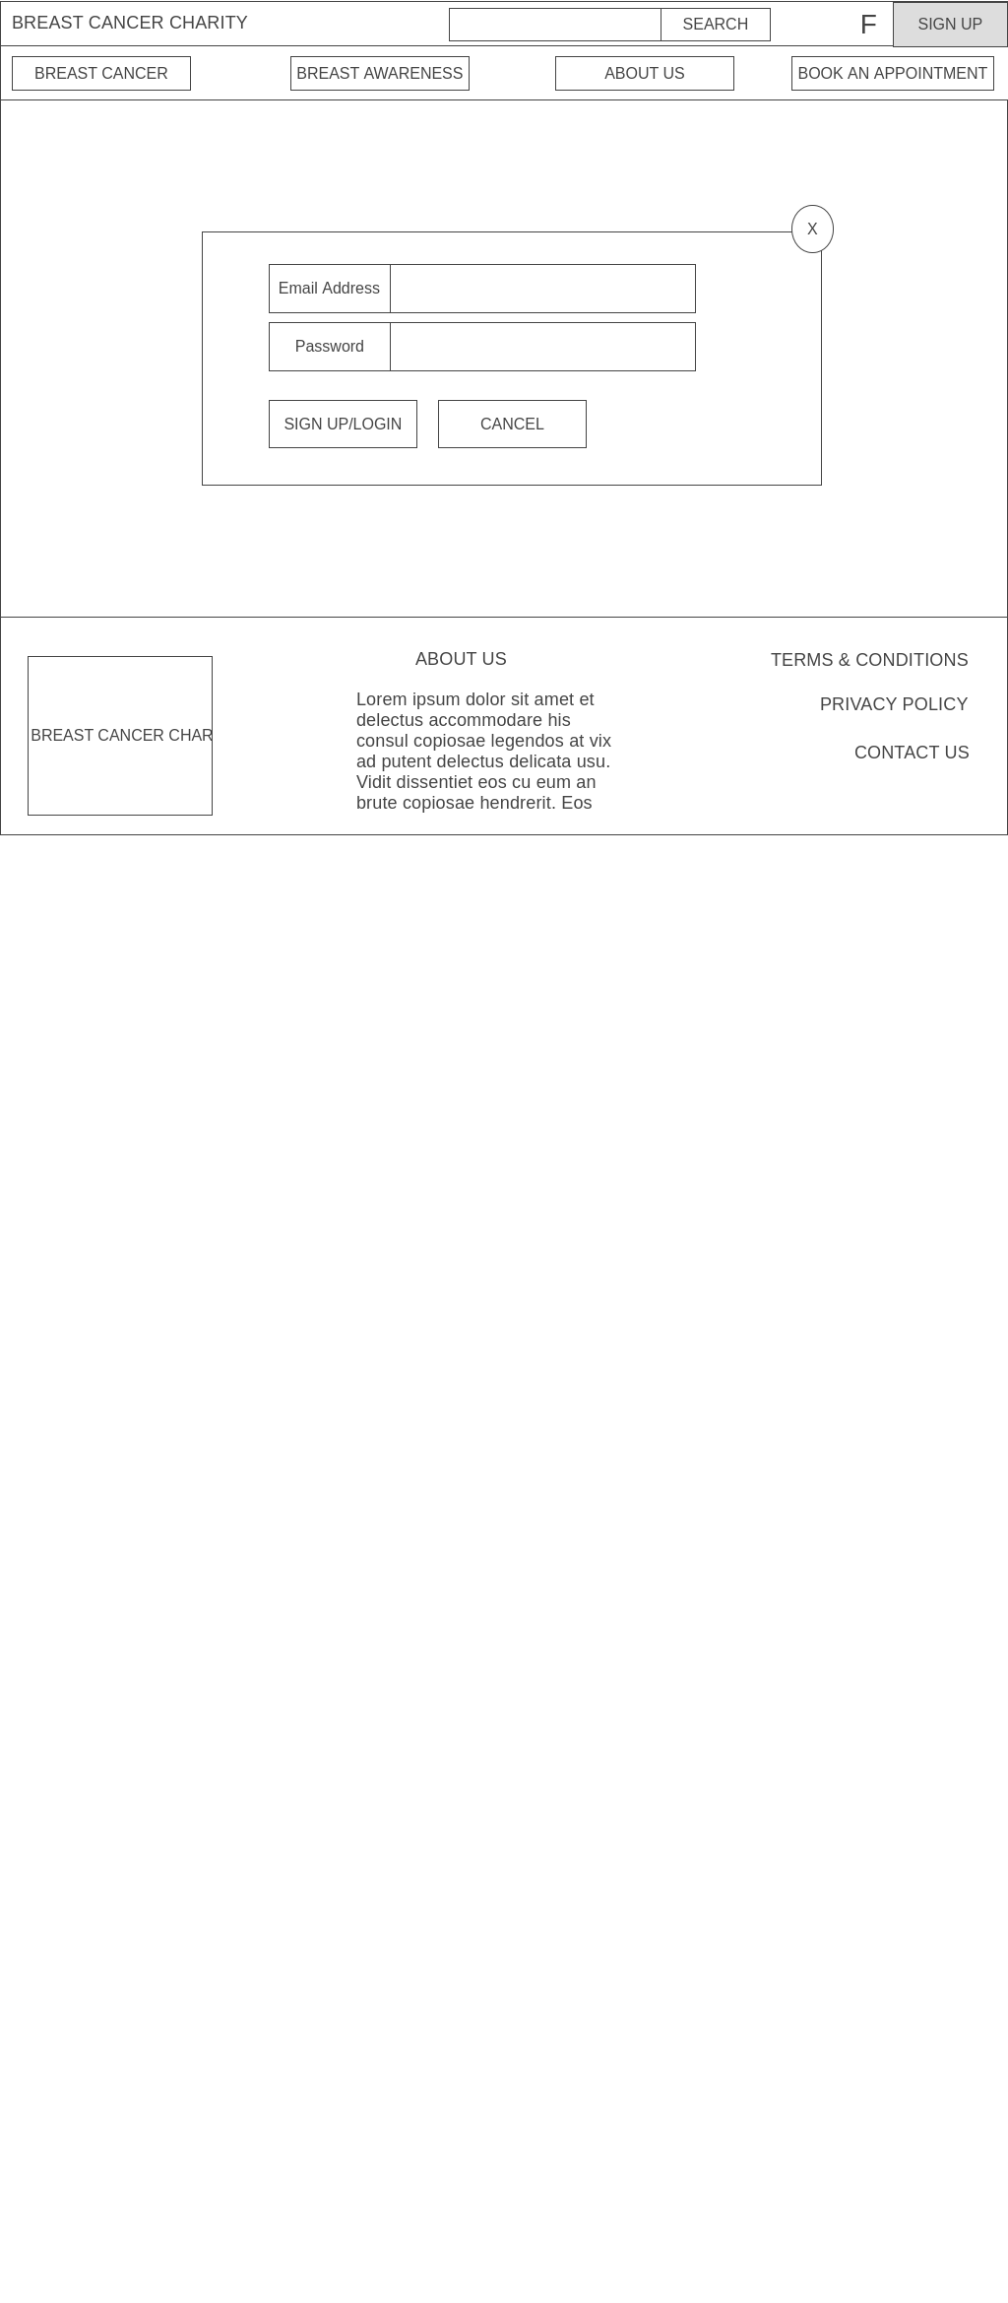

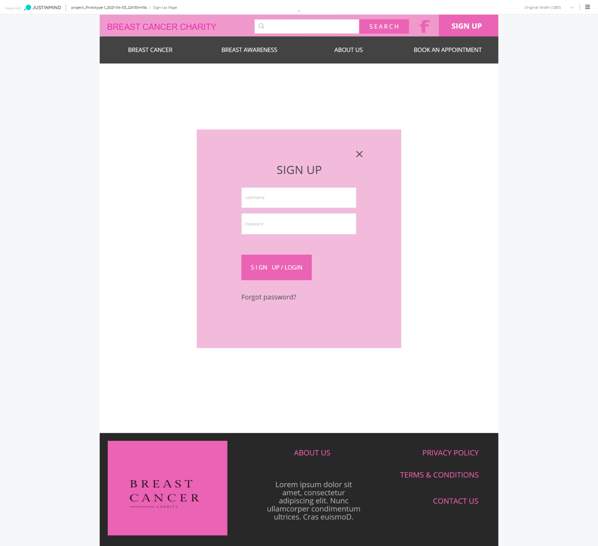

# Section 5 CRUD Analysis

## CRUD Table

|  |  |  |  |  |
| --- | --- | --- | --- | --- |
| UserID | Email Address | Password | Admin Email Address | Admin Password |
| C | C | C | C | C |
| R | R | R | R | R |
| R | RU | RU | RU | RU |
| R,D | R,D | R,D | R,D | R,D |
|  |  |  |  |  |

User Table

Task Manager Table

|  |  |  |  |
| --- | --- | --- | --- |
| TaskID | ListID | Task | List |
| C | C | C | C |
| R | R | R | R |
| R,D | R,D | R,U | R,U |
|  |  | R,D | R,D |

Booking Appointment Table

|  |  |  |
| --- | --- | --- |
| UserID | BookingID | Booking Details |
| R | C | C |
|  | R | R,U |
|  | R,D | R,D |

## API Prototype

Githib URL - <https://github.com/praptimane26/BreastCancerCharity>

Below is the link to the API prototype. I have created the Task manager API first, as it performs the same functions as the User, but I just decided to create and dabble with that one first. So far the API works fine it can create a list, retrieve, update and delete the list.

To run the API – in the API folder start Code and then enter in the terminal “nodemon app.js”

To run the frontend – in the frontend folder start code and then enter in the terminal “ng serve”

# References

*Wireframe.cc | The go-to wireframing tool.* (n.d.). Wireframe.Cc. Retrieved September 17, 2020, from <https://wireframe.cc/>

Devstackr. (2019, April 10). *Building the API | NodeJS, Express and Mongoose—[3] Build a Task Manager w/ MEAN Stack*. <https://www.youtube.com/watch?v=P3R-8jj3S7U>